

DEPARTMENT OF ELECTRONICS AND COMMUNICATION ENGINEERING

OPTICAL COMMUNICATION Lab

EC1425 Optical Communication and Networks (R-2024)

LIST OF EXPERIMENTS
- Measurement of Fiber Optic Loss

Study the Characterization of Optical Sources and Detectors

Optical Link Design and Performance Analysis

Wavelength Division Multiplexing (WDM) Simulation

Free-Space Optical Communication (FSO) Implementation

Optical Amplifier Performance Analysis

TOTAL: 30 HOURS

Experiment 1: Measurement of Fiber Optic Loss

AIM
To measure propagation loss & bending losses for two different wavelengths in plastic Fiber provided with the kit.
EQUIPMENTS REQUIRED
- Link-B Kit with power supply.
- Patch chords.
- 20MHz Dual Channel Oscilloscope.
- 1 MHz Function Generator.
- 1 Meter Fiber Cable.

THEORY

Optical Fibers are available in different variety of materials. These materials are usually selected by taking into account their absorption characteristics for different wavelengths of light. In case of Optical Fiber, since the signal is transmitted in the form of light which is completely different in nature as that of electrons, one has to consider the interaction of matter the radiation to study the losses in fiber.
Losses are introduced in fiber due to various reasons. As light propagates from one end of Fiber to another end, part of it is absorbed in the material exhibiting absorption loss. Also part of the light is reflected back or in some other directions from the impurity particles present in the material contributing to the loss of the signal at the other end of the Fiber. In general terms it is know as propagation loss. Plastic Fibers have higher loss of the order of 180 dB/Km.
Whenever the condition for angel of incidence of the incident lights is violated the losses are introduced due to refraction of light. This occurs when fiber is subjected to bending. Lower the radius of curvature more is the loss. Other losses are due to the coupling of Fiber at LED and photo detector ends.
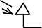
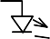
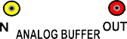
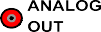
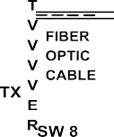
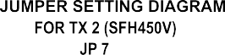
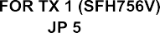

PROCEDURE :

PROCEDURE

- Connect the power supply with proper polarity to the kit link-B and switch it on.
- Keep all Switch Faults in OFF position.
- Keep switch SW8 towards TX position.
- Keep switch SW9 towards TX1 position.
- Keep Jumper JP5 towards +12V position.
- Keep Jumpers JP6, JP9, JP10 shorted.
- Keep Jumper JP8 towards sine position.
- Keep Intensity control pot P2 towards minimum position.
- Feed about 2Vpp sinusoidal signal of 1 KHz from the function generator to the IN post of Analog Buffer.

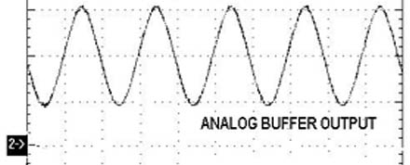

- Connect the output post OUT of Analog Buffer to the post TX IN of Transmitter.
- Slightly unscrew the cap of SFH756V (660nm). Do not remove the cap from the connector. Once the cap is loosened, insert the one meter fiber into the cap. Now tighten the cap by screwing it back.
- Connect the other end of the Fiber to detector SFH350V (Photo Transistor Detector) very carefully.
- Observe the detected signal at post ANALOG OUT on oscilloscope. Adjust Intensity control pot P2 Optical Power control potentiometer so that you receive signal of 2Vpp amplitude.

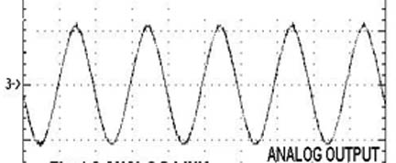

- Measure the peak value of the received signal at ANALOG OUT terminal. Let this value be V1.
- Now replace 1 meter Fiber by 3 Meter Fiber. Do not disturb any settings. Again take the peak voltage reading and let it be V2.

- If a is the attenuation of the Fiber then we have. P1/P2 = V1/V2 = e [ -a (L1+L2 ) ]

Where
a = nepers/ Meter
L1 = Fiber Length for V1 L2 = Fiber Length for V2
This a is for peak wavelength of 660nm
- Keep switch SW9 towards TX2 position.
- Keep Jumper JP7 towards +12V position.
- Remove fiber cable from SFH756V (660nm) & SFH350V and insert one meter fiber between SFH450V (950nm) & SFH350V.
- Observe the detected signal at post ANALOG OUT on oscilloscope.

- Measure the peak value of the received signal at ANALOG OUT terminal. Let this value be V1.
- Now replace 1 meter Fiber by 3 Meter Fiber. Do not disturb any settings. Again take the peak voltage reading and let it be V2.
- If a is the attenuation of the Fiber then we have. P1/P2 = V1/V2 = e [ -a (L1+L2 ) ]

Where
a = nepers/ Meter
L1 = Fiber Length for V1 ; L2 = Fiber Length for V2
This a is for peak wavelength of 950nm
- Compare the two a values.

MEASUREMENT OF BENDING LOSSES:
- Remove fiber cable from SFH450V (950nm) & SFH350V and insert one meter fiber between SFH756V (660nm) & SFH350V.
- Bend the Fiber in a loop. Measure the amplitude of the received signal.
- Keep reducing the diameter of bend to about 2 cm & take corresponding out voltage readings. (Do not reduce loop diameter less than 1 cm).
- Plot a graph of the received signal amplitude versus the loop diameter.

TABULATION:

PROPAGATION LOSS
Time period= --.

FIBRE LENGTH | Input amplitude(v) | Output amplitude(V)

BENDING LOSS Time period=----------------------

Bending diameter | Input amplitude(V) | Output amplitude(V)

RESULT:

Experiment 2: Characterization of Optical Sources and Detectors

Aim
To study characteristics of LEDs, LASER diodes, PIN photodiodes, and APDs.

Apparatus
- Optical sources (850/1310 nm), detectors, oscilloscope
- FOM-1A module, Optical patch cords.
- FOM-1B module, Optical patch cords.

Theory
I–V characteristics, responsivity, quantum efficiency, noise.
In an optical fiber communication system, the electrical signal is first converted into an optical signal using an E/O conversion device such as an LED. The optical signal is transmitted through the fiber and then retrieved in its original electrical form using an O/E conversion device such as a photo detector.
Key points:
- LEDs:
  - Emitters vary due to chip fabrication technologies.
  - Important parameters: peak wavelength, conversion efficiency, optical rise/fall times, max forward current, forward voltage.
  - Linear optical output with respect to forward current in a certain region.
- Photodetectors:
  - Types: photoconductive, photovoltaic, transistor-type, diode-type.
  - Important parameters: response time, wavelength sensitivity, responsivity.

Responsivity $R=\frac{I_{ph}}{P_{opt}}$, Quantum Efficiency $η=\frac{hc}{qλ}R$.

PROCEDURE for LED CHARACTERISTICS

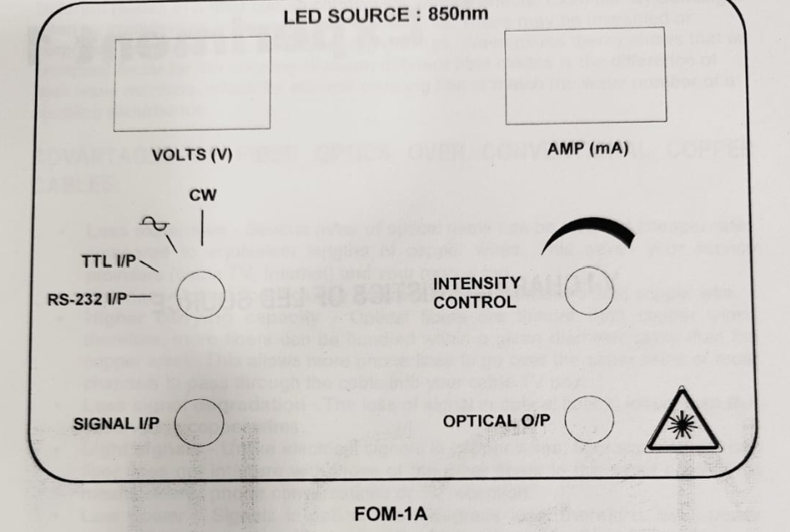
- Make sure that the FOM-1A module is OFF.
- Keep the intensity control plot fully anticlockwise.
- Keep signal selector switch on CW position.
- Turn ON the FOM-1A module. The current display should show 00.0 and the voltage display should show the garbage value.
- Turn the intensity control pot slightly in the clockwise direction, until the current display shows 00.1 mA.
- Record the current in mA and the corresponding voltage in volts.
- Repeat the procedure for current readings in steps of 00.1 mA upto the 45mA. Record the current in mA and the corresponding voltage in volts.
- Plot the graph for current (mA) vs Voltage (V).
- Find out the Threshold Current (I_th) in mA from the I-V graph.

PROCEDURE for LASER CHARACTERISTICS

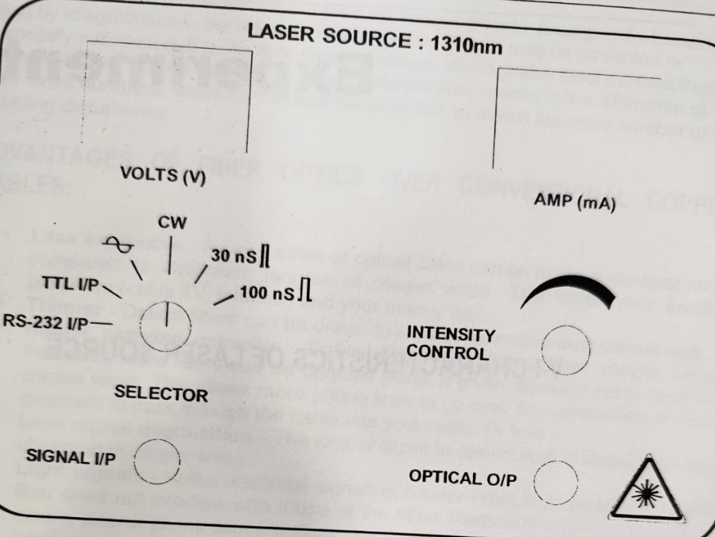
- Make sure that the FOM-1B module is OFF.
- Keep the intensity control plot fully anticlockwise.
- Keep signal selector switch on CW position.
- Turn ON the FOM-1B module. The current display should show 00.0 and the voltage display should show the garbage value.
- Turn the intensity control pot slightly in the clockwise direction, until the current display shows 00.1 mA.
- Record the current in mA and the corresponding voltage in volts.
- Repeat the procedure for current readings in steps of 00.1 mA upto the 45mA. Record the current in mA and the corresponding voltage in volts.
- Plot the graph for current (mA) vs Voltage (V).
- Find out the Threshold Current (I_th) in mA from the I-V graph.
Calculation
Measure photocurrent vs optical power.

Tabulation
Input optical voltage vs output current.

Optical voltage (V) | Photocurrent (µA) | Responsivity (A/W) | Quantum Efficiency (%)

Graph
I–V curve
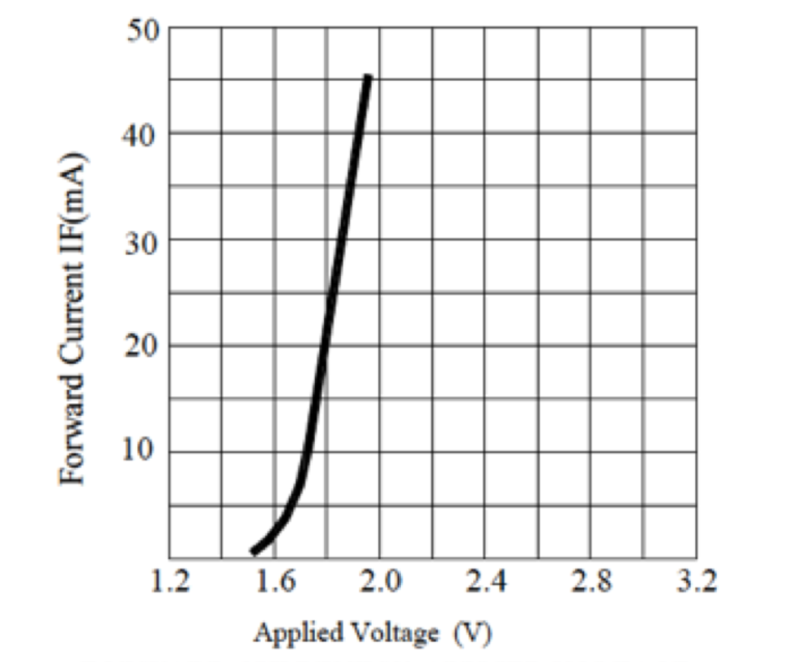

Result: Sources and detectors characterized with measured parameters.

Experiment 3: Optical Link Design

Aim
To design and analyze an optical link for BER and Q-factor.

Apparatus
Optiperformer software.

THEORY:
Optiwave introduces OptiPerformer, a free photonic design automation tool which harnesses the full power of OptiSystem and creates specific dynamic design scenarios which can be used by students.
In this exercise, you will download and install OptiPerformer on your PC/laptop. Your license of OptiPerformer will be capable of loading and running OptiSystem simulations prepared for this course.
Once you have installed OptiPerformer, you can copy the first file (named: ‘Introduction_OptiPerformer.osp’) to your PC and run the simulation. The first file is a basic fiber optic system consisting of a transmitter, a fiber and a receiver. The system is “instrumented” with an optical power meter at the input to receiver (or the output of the fiber) and a bit error rate (BER) analyzer.

Formula: Link Margin = Tx Power – Loss – Rx Sensitivity.
BER ≈ 0.5 erfc(Q/√2).

PROCEDURE:
1. Download and install OptiPerformer from the optiwave.com web site.
2. Copy the ‘Introduction_OptiPerformer.osp’ file to your PC
3. Start OptiPerformer
4. Use either the File menu or the Open File button to open the Fiber Optic System File.
5. Study the layout, which includes some text and boxes to identify the three components of the fiber optic system. The “transmitter” section includes a binary source (PRBS or pseudo-random bit sequence generator), an electrical pulse generator, a laser diode and an external modulator. The receiver section includes a photodiode, a low-pass filter and a decision circuit, which includes a BER analyzer. We will cover these components in more detail later in the course.
6. Run the simulation by pushing the start button. The progress of the simulation will be displayed and the message “Calculation Finished!” will appear when the simulation runs to completion.
7. Double click on the optical power meter and the BER analyzer and move the windows as necessary for clarity. Check the box next to “Show Eye Diagram” in the BER window. The optical power meter shows the power at the input to the photodiode in both watts and dBm. The BER window displays the “eye diagram” and several quantities including the “Max Q
Factor” and the “Min BER”.
8. The simulation is set to run 5 “iterations”, with the fiber length varying from 50 to 150 km in 5 steps. The index is displayed in the upper right corner of the layout. To step through the iterations, use the forward and reverse buttons in the lower left of the window. Note the change in received power and BER display (eye diagram, Q factor and BER) with fiber length.
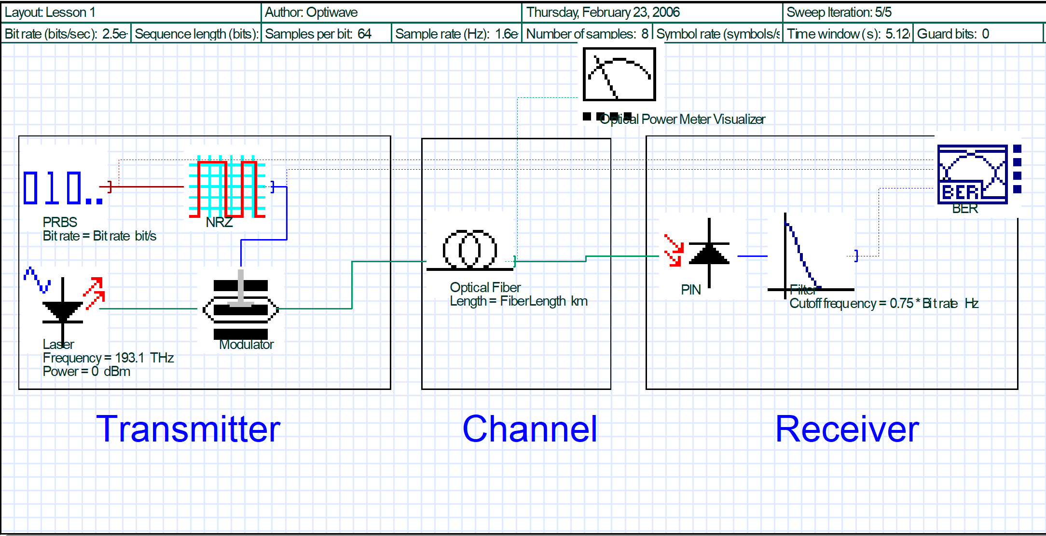

Calculation
Compute received power, BER

Tabulation
Fiber length vs BER/Q
S.No | Fiber Length | Optical Power |  | BER
S.No | Fiber Length | Watts | dBm | Max. Q Factor | Min BER | Eye Height | Decision Instant

MODEL GRAPH:
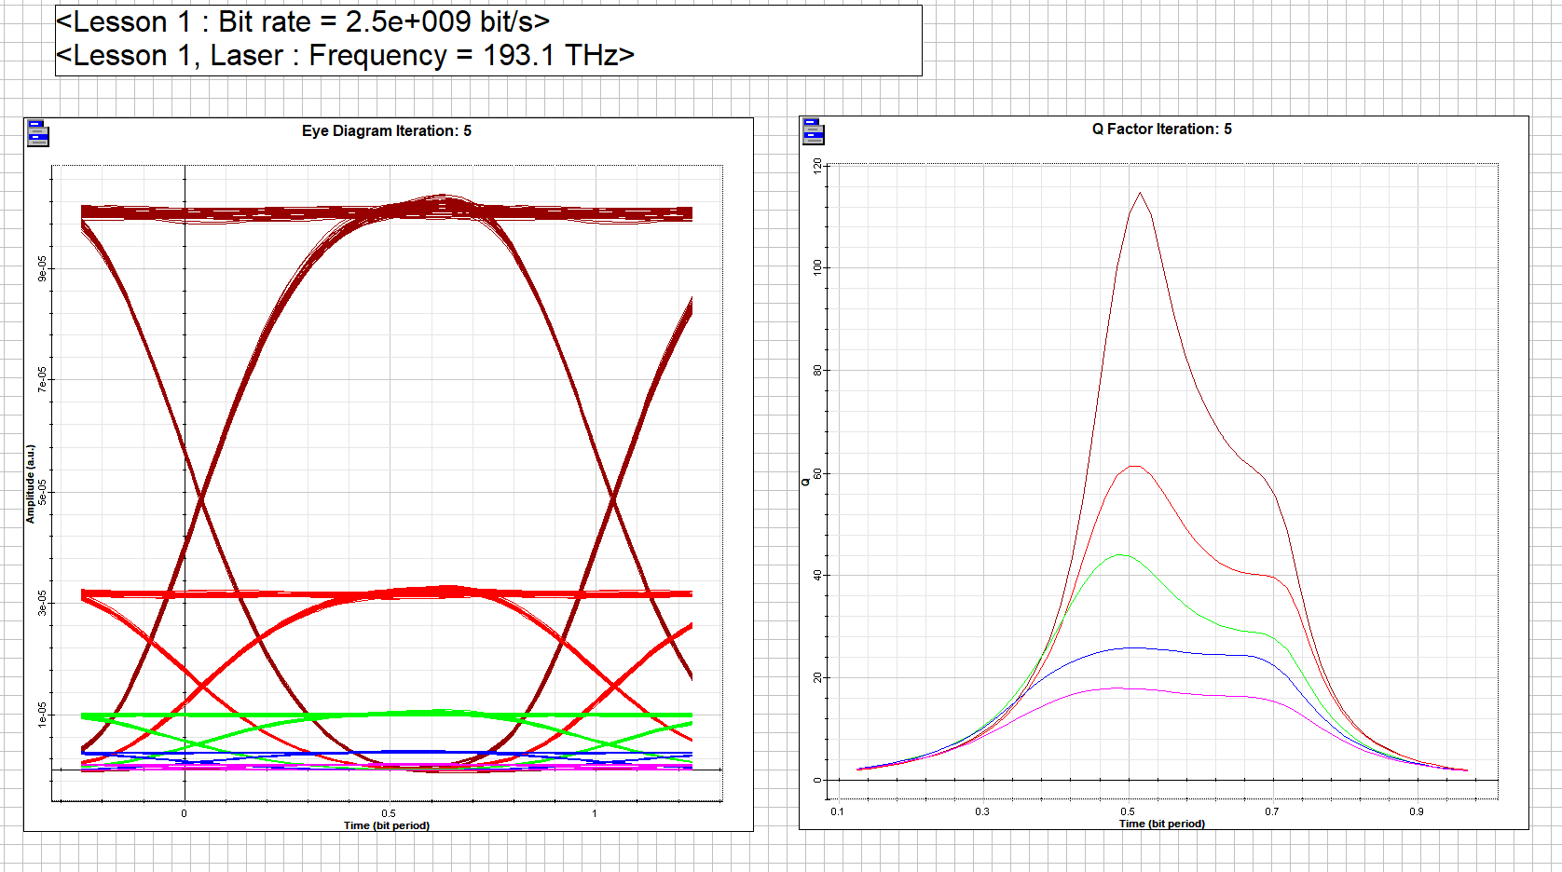
Result
Link performance evaluated.

Experiment: 4 Wavelength Division Multiplexing (WDM) Simulation
Aim
To simulate a WDM system using Python and analyze channel separation and insertion loss.
Apparatus/Software Required
- Python (NumPy)
- Google Colab or Jupyter Notebook
Theory
- WDM allows multiple optical signals at different wavelengths to be transmitted simultaneously over a single fiber.
- Channel spacing determines spectral efficiency and crosstalk.
- Insertion loss is the reduction in signal power due to multiplexing/demultiplexing.
Formula:
$$\text{Insertion Loss (dB)}=P_{in}-P_{out}$$
$$\text{Channel Spacing}=Δλ$$

1

Setup Environment
Info
Prepare Python environment for simulation.
- Import NumPy and Matplotlib
- Define channel wavelengths and powers

2

Define WDM Parameters
Specify input wavelengths and powers.
Example: λ = [1550, 1552, 1554] nm, Pin = -2 dBm
- Choose 3 channels
- Assign equal input power

3

Calculate Output Power
Simulate insertion loss for each channel.
Insertion Loss = Pin - Pout
- Assume ~1 dB loss per channel
- Compute Pout

4

Plot WDM Spectrum
Visualize channel separation.
- Use Matplotlib to plot wavelength vs power
- Label each channel peak

5

Analyze Results
Success
Interpret the simulation output.
- Channels separated with ~1–2 dB insertion loss
- Verify spacing Δλ = 2 nm

Python Code (Colab Cell)
import numpy as np
import matplotlib.pyplot as plt

# -----------------------------
# PARAMETERS
# -----------------------------
num_channels = 5
center_wavelength = 1550 # nm
channel_spacing = 0.8 # nm (can vary this!)
bandwidth = 0.2 # spectral width of each channel

# wavelength axis
wavelength = np.linspace(1545, 1555, 2000)

# -----------------------------
# GENERATE CHANNELS
# -----------------------------
channels = []

for i in range(num_channels):
lambda_i = center_wavelength + (i - num_channels//2) * channel_spacing

# Gaussian spectrum for each channel
spectrum = np.exp(-((wavelength - lambda_i)**2) / (2 * bandwidth**2))

channels.append(spectrum)

# -----------------------------
# MULTIPLEXED SIGNAL
# -----------------------------
wdm_signal = np.sum(channels, axis=0)

# -----------------------------
# PLOTS
# -----------------------------

# Individual channels
plt.figure()
for i, ch in enumerate(channels):
plt.plot(wavelength, ch, linestyle='--', label=f'Ch {i+1}')
plt.xlabel("Wavelength (nm)")
plt.ylabel("Power")
plt.title("Individual WDM Channels")
plt.legend()
plt.grid()
plt.show()

# Combined WDM signal
plt.figure()
plt.plot(wavelength, wdm_signal)
plt.xlabel("Wavelength (nm)")
plt.ylabel("Power")
plt.title("Multiplexed WDM Signal")
plt.grid()
plt.show()

spacings = [0.2, 0.8, 1.6]

plt.figure()

for spacing in spacings:
channels = []

for i in range(num_channels):
lambda_i = center_wavelength + (i - num_channels//2) * spacing
spectrum = np.exp(-((wavelength - lambda_i)**2) / (2 * bandwidth**2))
channels.append(spectrum)

wdm_signal = np.sum(channels, axis=0)
plt.plot(wavelength, wdm_signal, label=f'Spacing = {spacing} nm')

plt.xlabel("Wavelength (nm)")
plt.ylabel("Power")
plt.title("Effect of Channel Spacing in WDM")
plt.legend()
plt.grid()
plt.show()

Sample Output
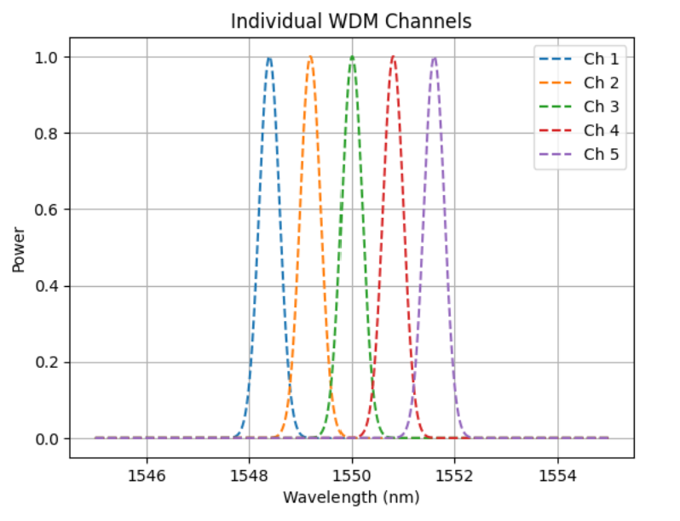
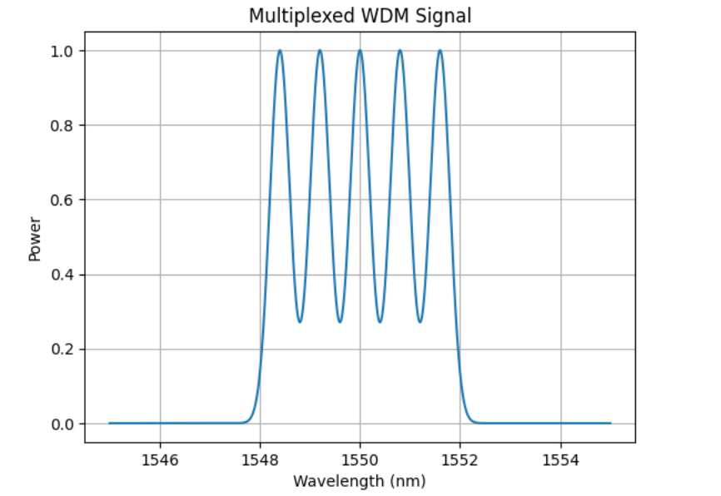
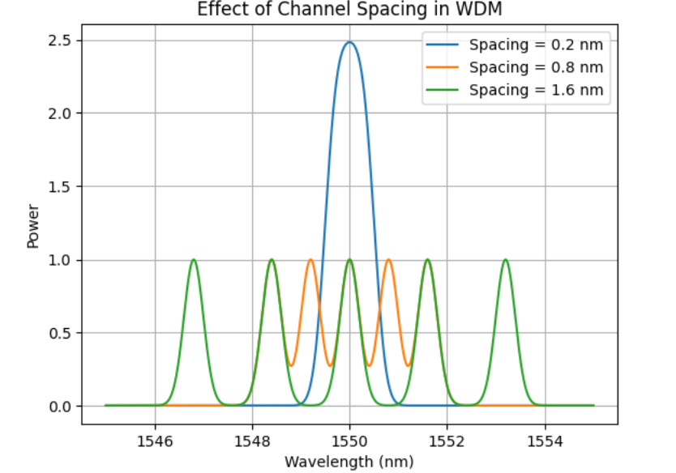
Result
Channels separated with ~1–2 dB insertion loss.

Experiment 5: Experiment: Free-Space Optical Communication (FSO)
Aim: To implement and analyze a free-space optical communication link using a laser/LED transmitter and photodiode/APD receiver.
Apparatus/Software Required:
Python Colab
Theory:
- FSO uses light beams to transmit data through free space instead of fiber.
- Performance depends on distance, alignment, and atmospheric attenuation.
- Received power decreases exponentially with distance.
Formula:
$$Loss=10⋅{log⁡}_{10}\left(\frac{P_{in}}{P_{out}}\right)$$

1

Setup the Transmitter
Info
Prepare the optical source for transmission.
- Use a Laser/LED source
- Mount it on an optical bench
- Ensure stable power supply

2

Align the Optical Path
Warning
Proper alignment ensures maximum received signal.
- Place transmitter and receiver in line of sight
- Adjust using lenses/mirrors if needed
- Minimize beam divergence

3

Connect the Receiver
Setup the photodiode/APD to detect the optical signal.
- Mount detector opposite to transmitter
- Connect to oscilloscope for signal observation
- Record received power

4

Measure Received Power
Collect data at different distances.
Loss = 10 log10(Pin / Pout)
- Vary distance (1 m, 5 m, 10 m, etc.)
- Note received power in µW
- Calculate link loss

5

Plot Graphs
Visualize performance of FSO link.
- Plot Received Power vs Distance
- Observe exponential decay trend
- Compare with theoretical model

6

Conclude Results
Success
Summarize findings of the experiment.
- Reliable communication up to ~10 m indoors
- Loss increases with distance
- Alignment critical for performance

Python/Colab Code

import numpy as np

import matplotlib.pyplot as plt

# -----------------------------

# PARAMETERS

# -----------------------------

lambda_nm = 1550 # wavelength (nm)

lambda0 = 550 # reference wavelength (nm)

L = 2 # link distance (km)

V_range = np.linspace(0.1, 20, 100) # visibility range (km)

R_range = np.linspace(0, 50, 100) # rain rate (mm/hr)

# -----------------------------

# KRUZE MODEL FUNCTION

# -----------------------------

def kruse_q(V):

if V > 50:

return 1.6

elif V > 6:

return 1.3

else:

return 0.585 * (V ** (1/3)) + 0.34

# Vectorize q

q_values = np.array([kruse_q(v) for v in V_range])

# -----------------------------

# ATTENUATION CALCULATION

# -----------------------------

alpha = (3.91 / V_range) * ((lambda_nm / lambda0) ** (-q_values))

# Total attenuation (dB)

tau = 4.343 * alpha * L

# -----------------------------

# RAIN ATTENUATION

# -----------------------------

A_rain = 1.076 * (R_range ** 0.67)

# -----------------------------

# PLOTS

# -----------------------------

# 1. Visibility vs Attenuation

plt.figure()

plt.plot(V_range, tau)

plt.xlabel("Visibility (km)")

plt.ylabel("Atmospheric Attenuation (dB)")

plt.title("FSO Attenuation vs Visibility (Kruze Model)")

plt.grid()

plt.show()

# 2. Rain attenuation

plt.figure()

plt.plot(R_range, A_rain)

plt.xlabel("Rain Rate (mm/hr)")

plt.ylabel("Rain Attenuation (dB/km)")

plt.title("Rain Attenuation in FSO Link")

plt.grid()

plt.show()

# 3. Wavelength impact

lambda_range = np.linspace(800, 1600, 100)

tau_lambda = []

for lam in lambda_range:

q = kruse_q(2) # fixed low visibility (fog)

alpha_l = (3.91 / 2) * ((lam / lambda0) ** (-q))

tau_l = 4.343 * alpha_l * L

tau_lambda.append(tau_l)

plt.figure()

plt.plot(lambda_range, tau_lambda)

plt.xlabel("Wavelength (nm)")

plt.ylabel("Attenuation (dB)")

plt.title("Attenuation vs Wavelength (Fog Condition)")

plt.grid()

plt.show()

Sample Output
Graph: Received Power vs Distance (decay curve)
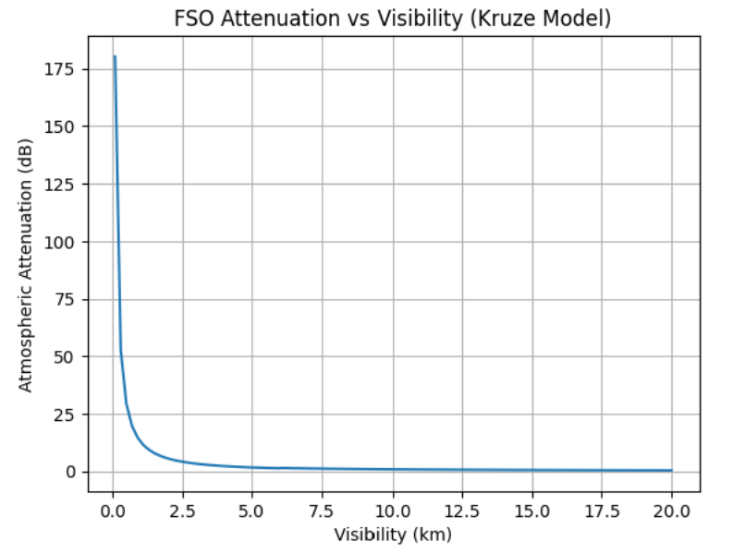
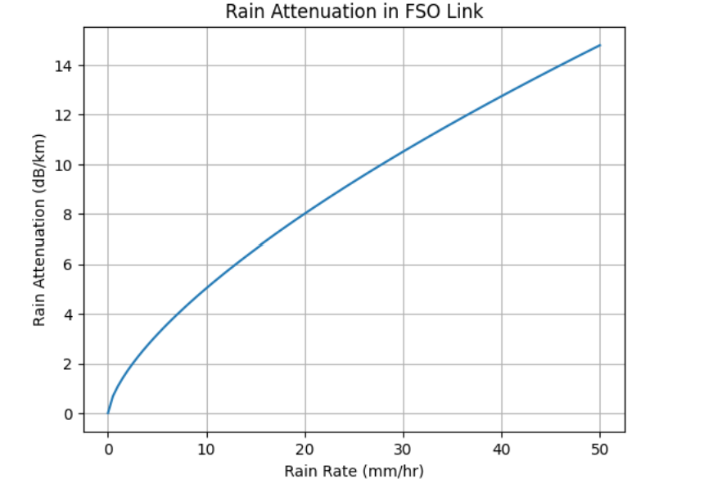
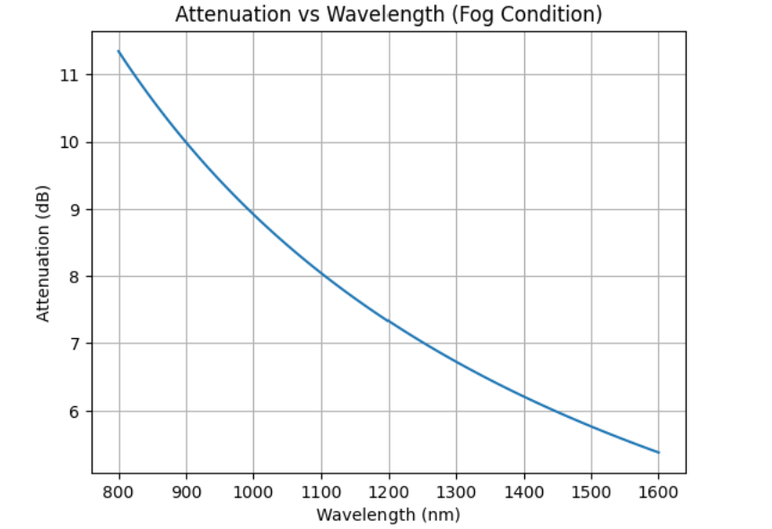
Result
Reliable FSO link up to ~10 m indoors; beyond that, signal quality degrades significantly.

Experiment 6: Optical Amplifier (EDFA) Performance Analysis
Aim: To study the gain and noise performance of an Erbium-Doped Fiber Amplifier (EDFA) using Python simulation.
Apparatus/Software Required:
- Python (NumPy) in Google Colab
Theory:
- EDFA amplifies optical signals in the C-band (1530–1565 nm) using stimulated emission.
- Gain depends on wavelength and pump power.
- Noise figure quantifies SNR degradation.
Formulas:
Key Equations
1. Gain
Amplifier gain:
$$G=\frac{P_{out}}{P_{in}}$$
Gain in dB:
$$G_{dB}=10{log⁡}_{10}\left(\frac{P_{out}}{P_{in}}\right)$$

2. ASE Power
$$P_{ASE}=2n_{sp}(G-1)hνB_{o}$$
where:
- $n_{sp}$= spontaneous emission factor
- $G$= amplifier gain (linear)
- $h$= Planck's constant
- $ν$= optical frequency
- $B_{o}$= optical bandwidth

3. Noise Figure
Noise Factor:
$$F=\frac{SNR_{in}}{SNR_{out}}$$
For EDFA:
$$F=2n_{sp}\frac{G-1}{G}$$
Noise Figure in dB:
$$NF=10{log⁡}_{10}(F)$$
For high-gain EDFAs ($G≫1$):
$$NF≈10{log⁡}_{10}(2n_{sp})$$
Typical commercial EDFAs have:
$$NF≈4\text{–}6\text{ dB}$$

Typical Practical Values
Parameter | Typical Value
Pump wavelength | 980 nm / 1480 nm
Signal wavelength | 1530–1565 nm
Peak gain | 25–40 dB
Saturation output power | 10–23 dBm
Noise figure | 4–6 dB
Fiber length | 5–20 m

Python/Colab Code
python

import numpy as np

import matplotlib.pyplot as plt

# -----------------------------

# Constants

# -----------------------------

h = 6.626e-34

c = 3e8

lambda_s = 1550e-9

nu = c / lambda_s

# -----------------------------

# Parameters

# -----------------------------

n_sp = 1.2

B = 50e9

Pin = 1e-6 # input signal power

# -----------------------------

# 1. Gain vs Pump Power

# -----------------------------

pump_power = np.linspace(0.01, 0.2, 50) # W

# Simple saturation-like gain model

G_linear = 1 + 50 * (pump_power / (pump_power + 0.05))

G_dB = 10 * np.log10(G_linear)

# -----------------------------

# 2. Gain Spectrum

# -----------------------------

wavelength = np.linspace(1525, 1565, 100)

# Gaussian EDFA gain profile (C-band)

G_spec = 30 * np.exp(-((wavelength - 1535)/10)**2)

# -----------------------------

# 3. Noise Figure

# -----------------------------

F = 2 * n_sp * (G_linear - 1) / G_linear

NF_dB = 10 * np.log10(F)

# ASE power

P_ASE = 2 * n_sp * (G_linear - 1) * h * nu * B

# -----------------------------

# Plots

# -----------------------------

plt.figure()

plt.plot(pump_power, G_dB)

plt.xlabel("Pump Power (W)")

plt.ylabel("Gain (dB)")

plt.title("Gain vs Pump Power")

plt.grid()

plt.figure()

plt.plot(wavelength, G_spec)

plt.xlabel("Wavelength (nm)")

plt.ylabel("Gain (dB)")

plt.title("EDFA Gain Spectrum")

plt.grid()

plt.figure()

plt.plot(G_dB, NF_dB)

plt.xlabel("Gain (dB)")

plt.ylabel("Noise Figure (dB)")

plt.title("Noise Figure vs Gain")

plt.grid()

plt.show()

Sample Output

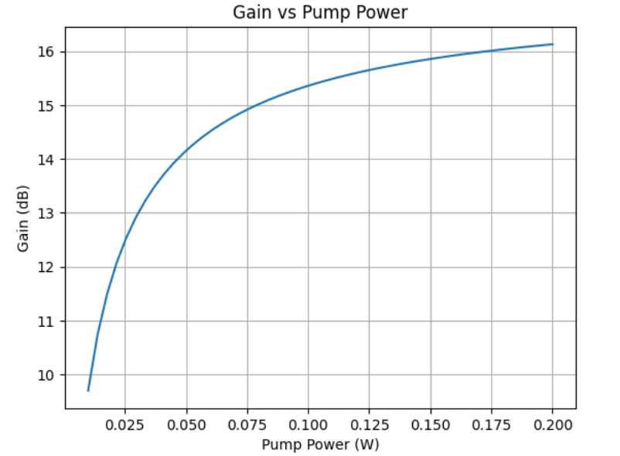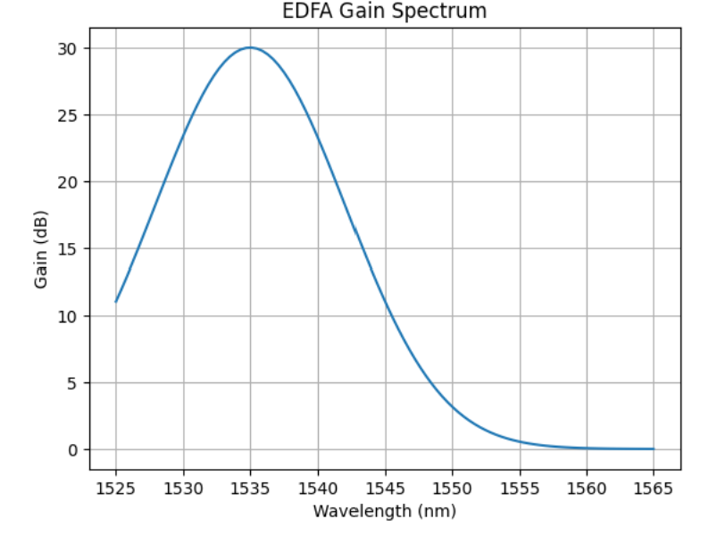

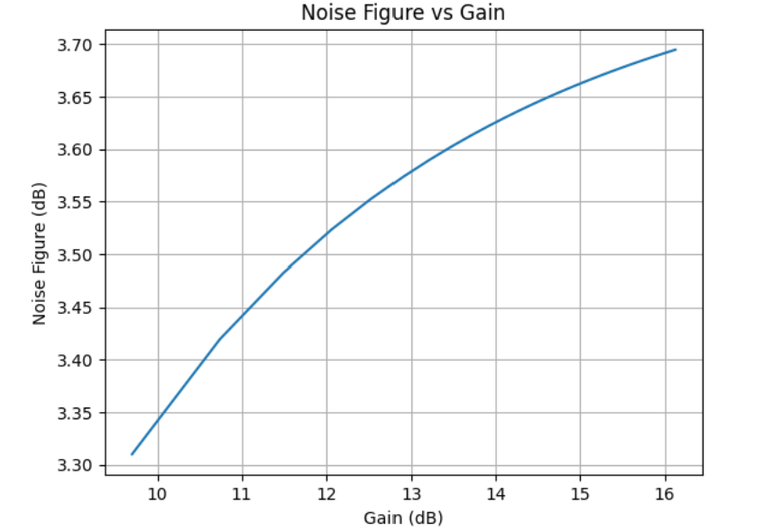
- Graph: Gain spectrum curve peaking near 1550 nm.
Result
EDFA provides ~20–24 dB gain with ~5 dB noise figure.

